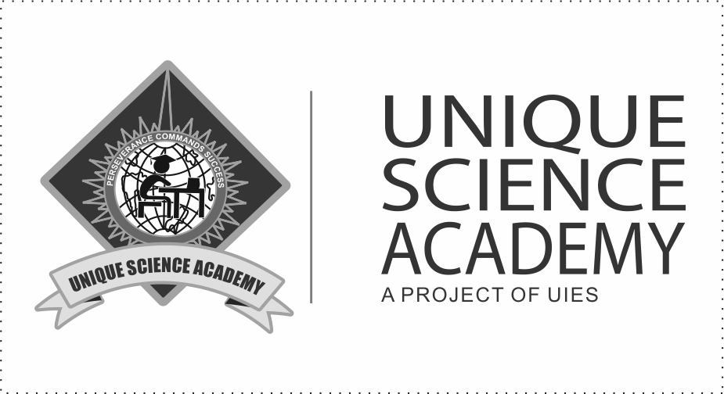**Unique Science Academy, 60 – D Nawab Town, Lahore**

**Statistics 12 Monthly Test**

(Chapter 14 – Simple Linear Regression & Correlation)

08 July 2024 Allowed Time : 40 minutes

|  |  |  |  |  |  |  |  |  |  |
| --- | --- | --- | --- | --- | --- | --- | --- | --- | --- |
| $$X_{i}$$ | 5 | 6 | 8 | 10 | 12 | 13 | 15 | 16 | 17 |
| $$Y_{i}$$ | 16 | 19 | 23 | 28 | 36 | 41 | 44 | 45 | 50 |

Total Marks: 20

**Question: The following data is given as follows:**

Marks

1. Calculate Regression coefficients. (3)
2. Fit a straight-line using X as independent variable. (2)
3. Estimate linear line using Y as independent variable (2)
4. Estimate Y when X = 20. (0.5)
5. Estimate X when Y = 32. (0.5)
6. Calculate the fitted / trend values for $\hat{Y}$. (5)
7. Prove that $\sum_{i=1}^{n}{Y_{i}}=\sum_{i=1}^{n}{\hat{Y}}$. (2)
8. Compute coefficient of correlation and interpret the result. (4+1)